Deliverable 3:

Customer Management system :
Identified noun | Notes on including noun as a thing to store
Customer | Yes, a key entity with lots of details required (profile, history, status). Include.
Customer Support Agent | This is an Actor. Their data is stored in the Employee class. Exclude.
Customer Profile | A synonym for the information stored in the Customer class. Exclude.
Personal Details | Attributes (name, email, phone) of the Customer class. Exclude.
Order History | A collection of Order objects associated with a Customer. Not a separate thing. Exclude.
Complaints History | A collection of Complaint objects associated with a Customer. Not a separate thing. Exclude.
Order | A core entity, primarily managed by the Order subsystem but critically related to Customer.  Include as a related class.
Order Status | A specific attribute (e.g., "Processing", "Delivered") of the Order class. Exclude.
Order Details | The attributes and items that make up an Order. Not a separate entity. Exclude.
Delivery Info | Information (like address, notes) that is an attribute of the Order class. Exclude.
Rider | An Actor and an entity from the Delivery subsystem. This subsystem only needs to view rider info. Exclude.
Message | Yes, a unique communication that must be stored, tracked, and linked to a Customer. Include.
Complaint | Yes, a unique entity the system needs to track, manage, and link to a Customer and Employee. Include.
Complaint Status | A specific attribute (e.g., "New", "Resolved") of the Complaint class. Exclude.
Alert / Notification | A transient output of the system, not a persistent entity. Exclude.
Customer Segment | Yes, a unique grouping of customers that the system needs to remember and manage. Include.
Purchase Frequency | A calculated value (derived attribute) about a Customer. Exclude.
Order Value | An attribute of a specific Order or a derived value for a Customer. Exclude.
Region | A piece of information (attribute) about a Customer's address. Exclude.
Customer Summary Report | An output (report) produced from other information. Not stored as an entity. Exclude.
Customer Activity Summary | An output (report). A synonym for a type of report. Exclude.
Customer Satisfaction Survey | The form is an output. but covered by The CustomerFeedback (the result) is a stored entity. Exclude
Active Customer List | An output (a filtered list/view of Customer entities). Not a stored entity. Exclude.
Account | A synonym for Customer in this context. Exclude.
Support Ticket | A synonym for Complaint. Exclude.
Customer Feedback | The SurveyResponse (the result) is a stored entity. Exclude (but include SurveyResponse).
Customer Status | A specific attribute (e.g., "Active", "Inactive") of the Customer class. Exclude.
SurveyResponse | Yes, a unique piece of feedback linked to a Customer and Complaint that must be stored for reporting. Include.
Employee | Yes, a key entity representing all internal users (agents, dispatchers, managers) with their own data and relationships. Include.

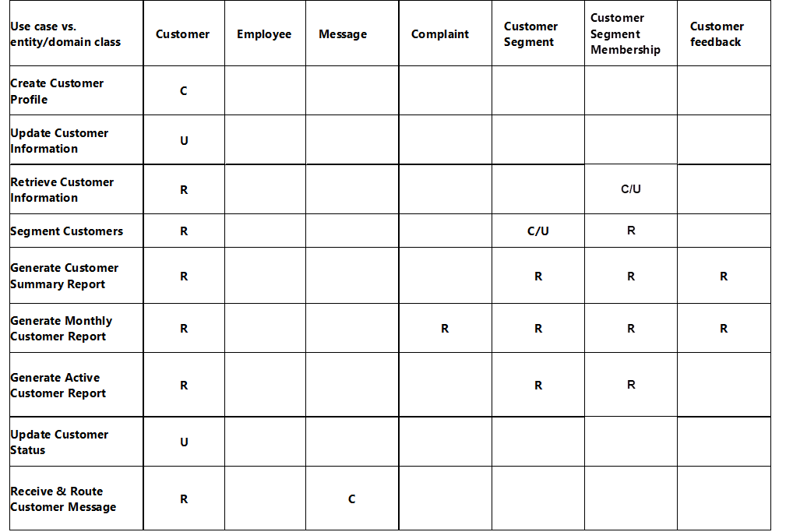
Crud Technique :

Order subsystem
Noun | Include/Exclude/Research | Reason
Customer | INCLUDE | Unique entity, system must store and remember multiple customers
Customer Support Agent | EXCLUDE | Actor, interacts with order retrieval
Manager | EXCLUDE | Actor for analytics/reporting
Delivery Rider | EXCLUDE | Actor, updates delivery completion
Order | INCLUDE | Core business object
Order Status | EXCLUDE | Not a class; becomes attribute of Order
Order Report/Performance | EXCLUDE | Output generated → not a class
Weekly Delivery Report | EXCLUDE | Output report → not a class
Order State | EXCLUDE | Part of Order lifecycle
Delivery | INCLUDE | Represents delivery entity tied to an order
Cancellation | EXCLUDE | It’s an action, not stored as separate object
Refund | INCLUDE | Important business object (may relate to cancelled orders)
Alert | INCLUDE | System sends inventory alert (state event)
Tracking | EXCLUDE | Not a class
Performance | EXCLUDE | Part of reports; not stored independently
Order History | EXCLUDE | Stored in Order entity
Inventory Staff | EXCLUDE | Covered under Inventory System (external to subsystem)
Stock | EXCLUDE | Belongs to Inventory System
System Clock | EXCLUDE | External trigger
Dispatcher | EXCLUDE | Might be role → actor, not class
Kitchen | EXCLUDE | Not an information entity
Product | INCLUDE | Items being ordered, needed for order details
OrderItem | RESEARCH | Needed to link Order and Product with quantities

CRUD
Use case vs. entity/domain class | Customer | Order | Refund | Product | Order Item | Delivery | Alert
Retrieve Order Status | R | R |  |  |  | R
Generate Order Report | R | R | R | R |  | R
Cancel Order |  | U | C |  | U |  | C
Generate Weekly Delivery Report | R | R |  |  | R | R
Change Order State |  | U |  |  |  |  | C
Complete Order |  | U |  |  |  | U | C
Notify Inventory Staff |  |  |  | R |  |  | C

Inventory and supplier subsytem:
Noun | Include/Exclude/Research | Reason
Supplier | INCLUDE | Core entity
Supplier Details | EXCLUDE | Attribute of Supplier
Contact Info | EXCLUDE | Part of Supplier
Address | EXCLUDE | Part of Supplier
Product | INCLUDE | Core inventory item
Purchase Order (PO) | INCLUDE | Major transaction class
Stock Delivery | INCLUDE | Represents received shipment
Inventory | INCLUDE | Holds stock details
Stock Quantity | EXCLUDE | Attribute of Inventory
Restocking | EXCLUDE | Process, not stored
Adjustment | INCLUDE | Represents a stock adjustment record
Threshold | EXCLUDE | Part of Inventory
Low-Stock Alert | INCLUDE | System entity
Purchasing Officer | EXCLUDE | Actor
Warehouse Staff | EXCLUDE | Actor
Inventory Manager | EXCLUDE | Actor
Sales Report | EXCLUDE | Generated output
Demand Report | EXCLUDE | Generated output
POItem | RESEARCH | Association class that emerges from PurchaseOrder-Product relationship

CRUD
Use Case / Activity | Product | Supplier | Purchase Order | Inventory | Low Stock Alert | Stock Adjustment | POItem | Stock Delivery
Add Supplier Details |  | C
Edit Supplier Information |  | R/U
Record Purchase Order | R | R | C |  |  |  | C
Record Restocking | R/U |  | R/U | R/U | R |  | R | C
Record Stock Adjustment | R/U |  |  | R/U |  | C
Generate Inventory Report | R | R | R | R | R | R | R | R
Generate Sales and Demand Report | R |  |  | R
Generate Low-Stock Alert | R |  |  | R | C
Close Purchase Order |  |  | R, U

Analytics subsystem:
Use Case / Class | Employee |  | Report | Customer | Segment | Order | OrderItem | Product | Inventory | Shipment
Sales Dashboard | R |  | C | – | – | R | R | – | – | –
Inventory Report | R |  | C | – | – | R | R | R | R | –
Segmentation Analysis | R |  | C | – | R | — | — | — | — | –
Daily Summary | R |  | C | R | — | R | R | R | R | R
Real-Time Update | R |  | U | U | R | R | R | R | R | R
Weekly Delivery Report | R |  | C | — | — | R | — | — | — | R

Delivery and dispatch subsystem :
Identified Noun | Notes on Including as a Thing to Store
Order | Yes. Core entity that must be tracked during dispatch. Include.
Rider | Yes. Represents delivery personnel with attributes & performance data. Include.
Delivery Dispatcher | Actor. Their data is stored in Employee. Exclude.
Order Pickup | Event, not an entity. Exclude.
Order Delivery | Event/Action, not a persistent thing. Exclude.
ETA (Estimated Time of Arrival) | Specific information related to delivery. Part of ETARecord. Include as a class.
ETA Notification | System output, not stored. Exclude.
Delay Alert | Yes. A unique alert generated when the system detects delay. Include.
Assignment | A unique mapping/order of which rider handles which delivery. Include as DeliveryAssignment.
Delivery Status | Attribute of the Order (Picked Up, In Transit, Delivered). Exclude.
Rider Performance | Derived metrics, not an entity. Exclude.
Delivery Performance Report | A report output produced by system. Exclude.
Tracking Data | Could be part of rider's location history. Needs research. Research.
Location | Attribute inside tracking data. Exclude.
Timestamp | Attribute. Exclude.
Customer | Related entity from Customer subsystem, not stored here. Exclude.
Delivery Zone | Attribute of Assignment or Order. Research.
Dispatch Queue | System process, not a stored persistent entity. Exclude.
Rider Availability | Attribute of Rider class. Exclude.
Delivery Delay | Same as Delay Alert (included as DelayAlert). Exclude duplicate.
System Clock | Actor/trigger, not a class. Exclude.
State (In Transit, Delivered, etc.) | Attribute of Order class. Exclude.
Notification | System output; not a stored entity. Exclude.

Crud
Use Case vs. Entity | Order | Rider | ETA Record | DelayAlert | Delivery Assignment | Customer | Employee
Assign Order to Rider | U | R |  |  | C | R
Record Order Pickup | U |  |  |  | U
Record Order Delivery | U |  |  |  | U
Notify Customer of ETA | R | R | C |  | R | R
Flag Potential Delivery Delay | R |  | R | C | R

Domain Class diagrams:
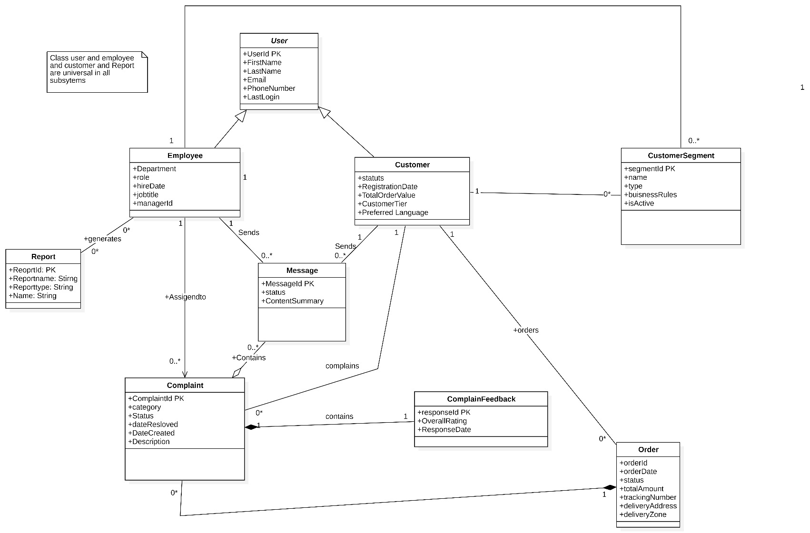
Customer Management:

Order class is the same one as the order class in order Subsystem ( Needed to be shown the relation )

Delivery and dispatch system:
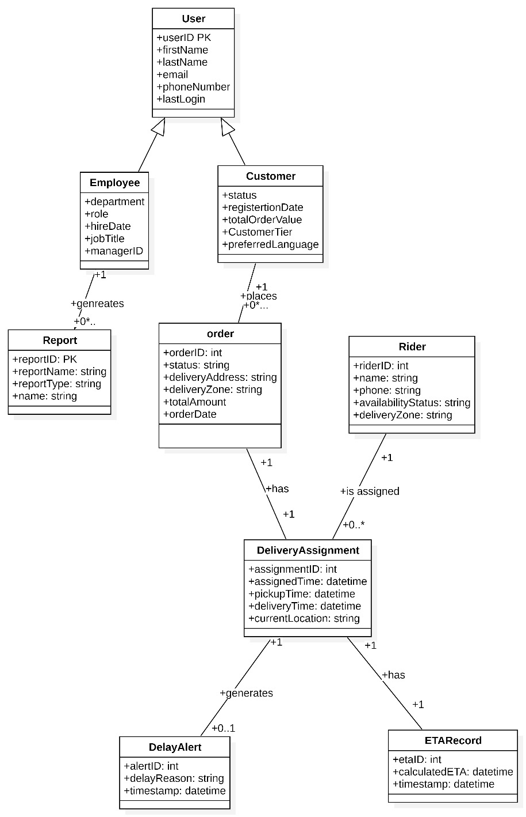

Inventory and supplier subsystem:
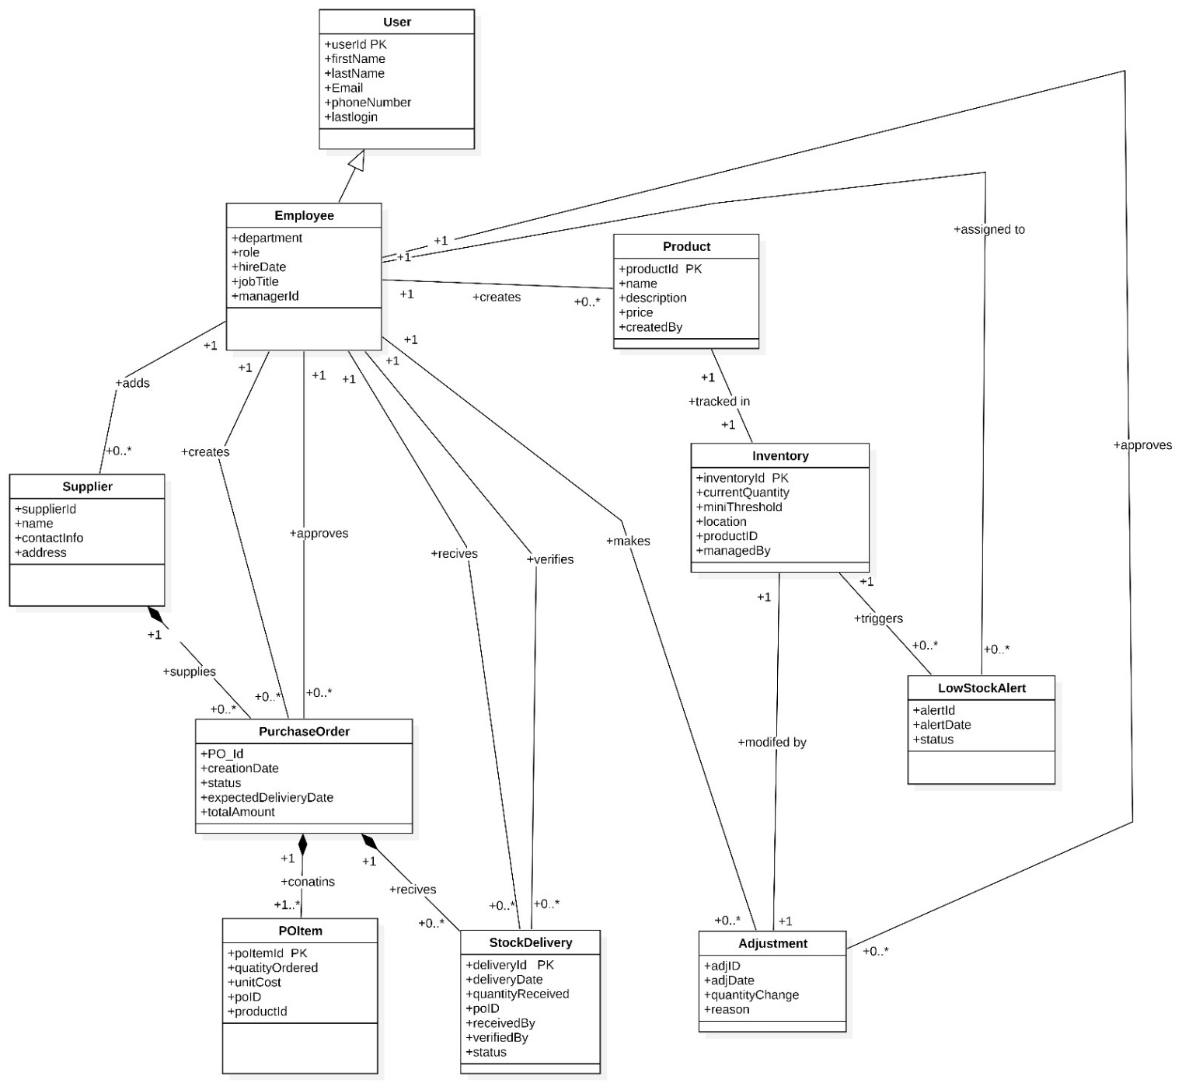
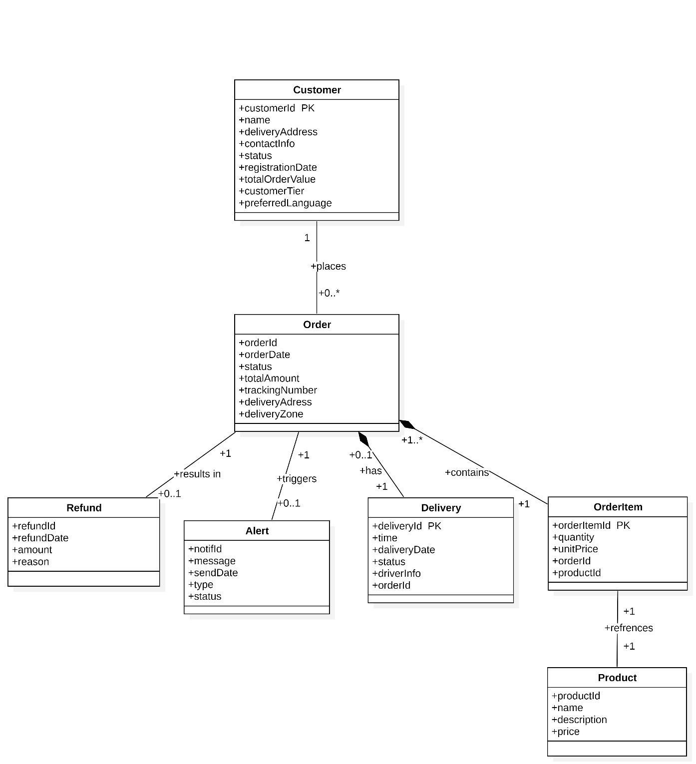
Order Management system:

Analytics subsystem:
Please note that this subsystem doesn’t have a domain class diagram as we discovered it is connected to all subsystems therefore it was redundant to model this subsystem.
Also, the dashboard can’t be a class as it is a design element so there were not any more classes
So, the class: Report belongs to the analytics subsystem
Another Note:
Customer, User and Employee, Order are universal class in all subsystem so we could not remove it from the other systems.

Activity Diagrams:
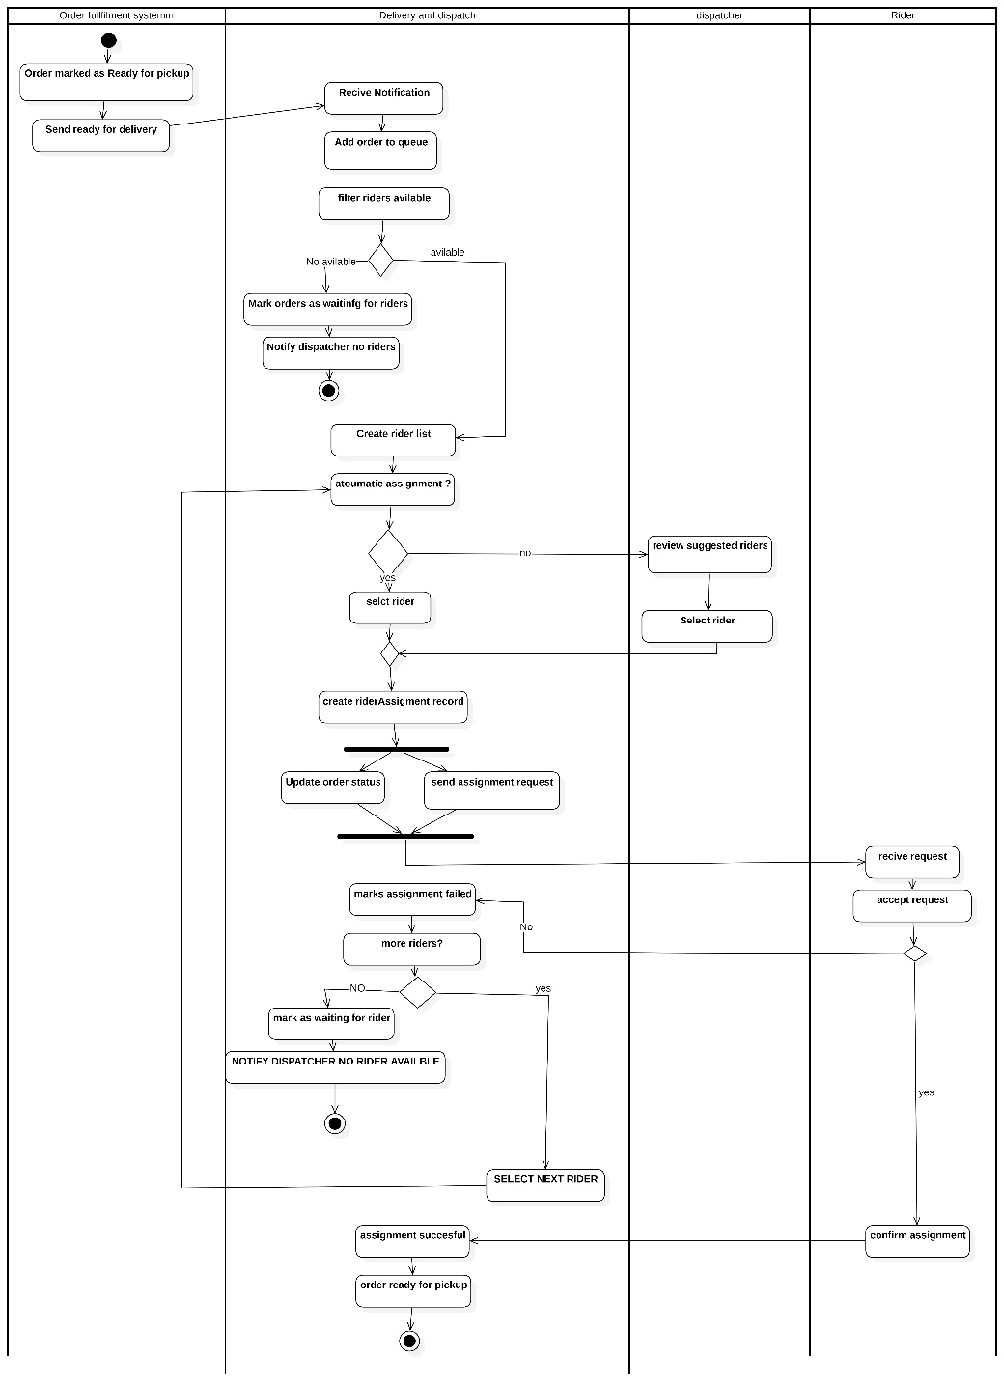
Assign Order

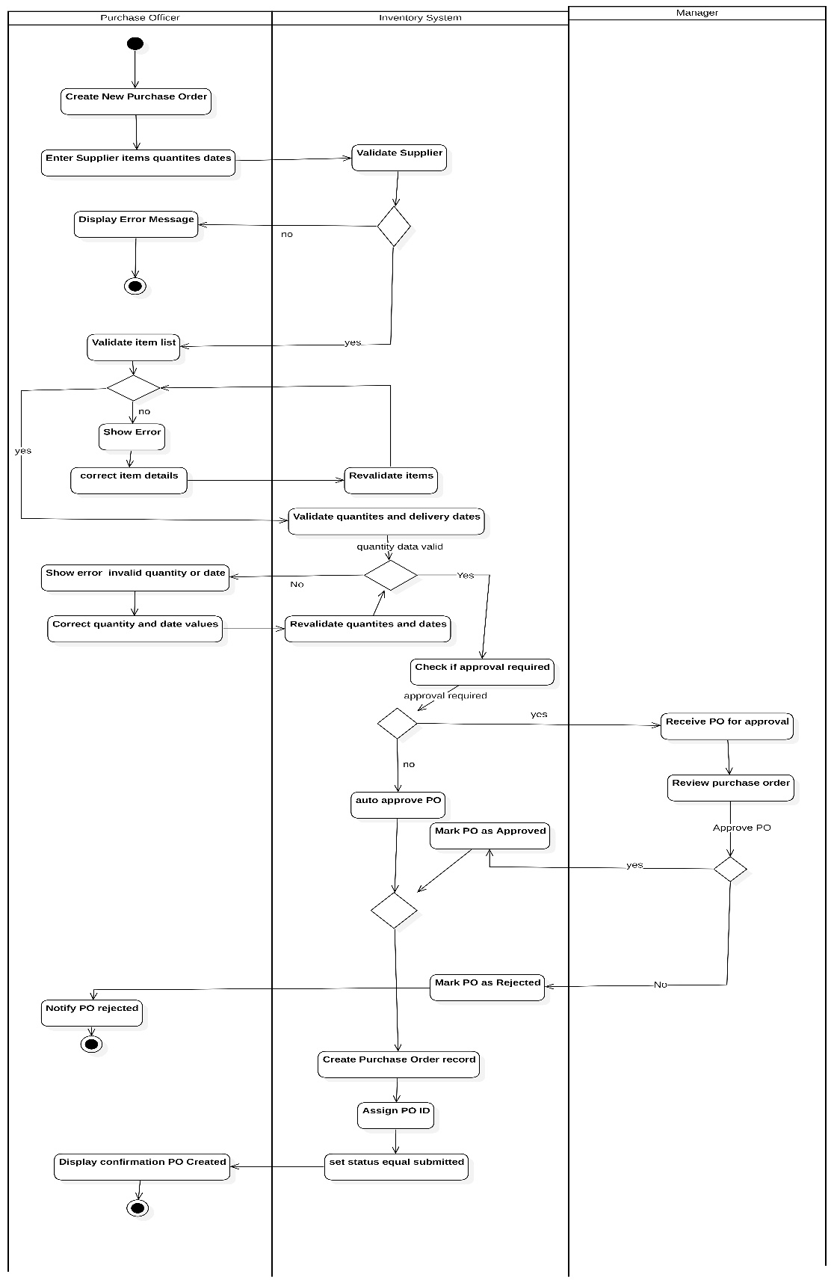
Record Purchase order:
Receive and route customer message:
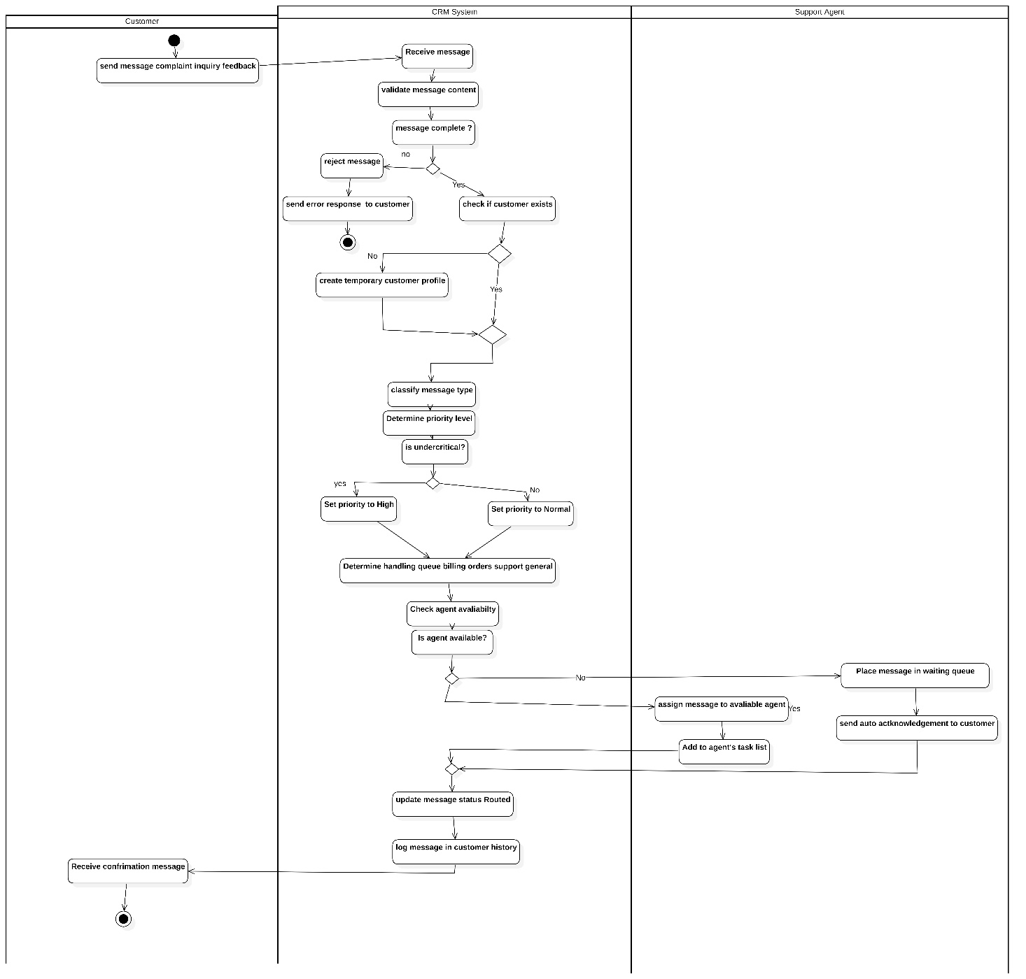

System sequence diagrams:
Side note :we couldn’t do sequence digrams for all the use cases so we illustrated some of the use cases.
Analytics Dashboard:
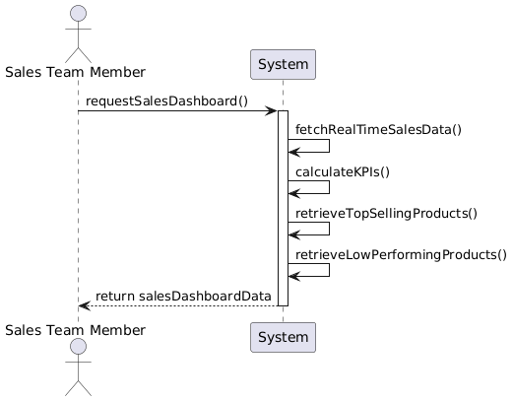
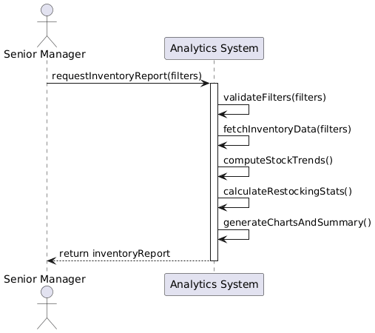
Generate Inventory Report Generate sales Dashboard

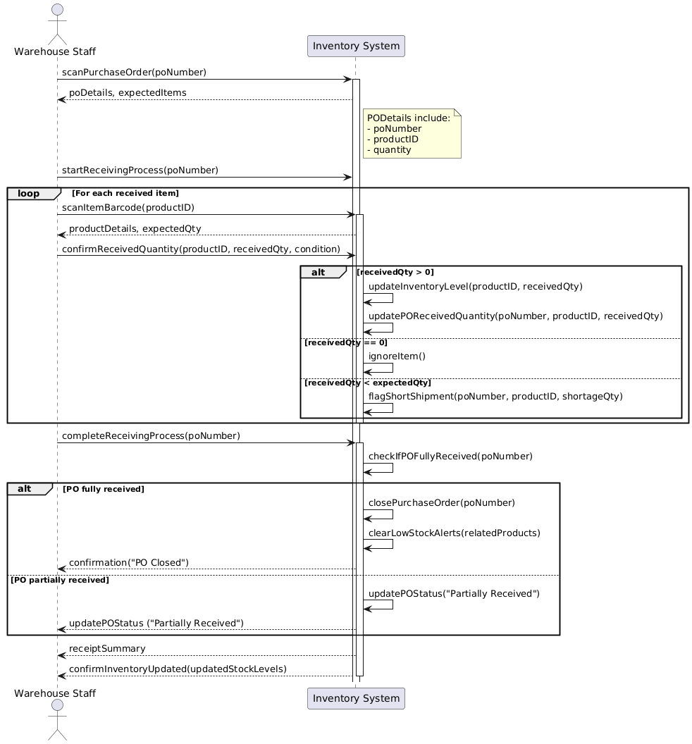
Record Restoking :

Customer Management:
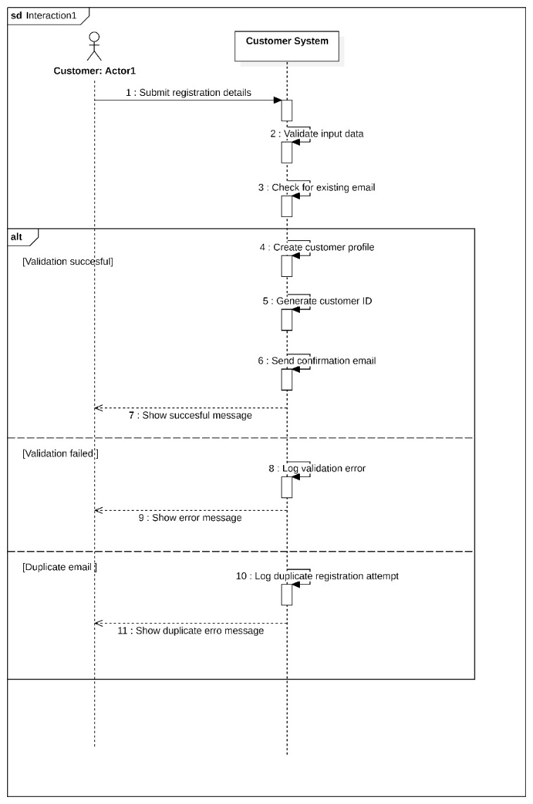
Update customer information Create customer Profile
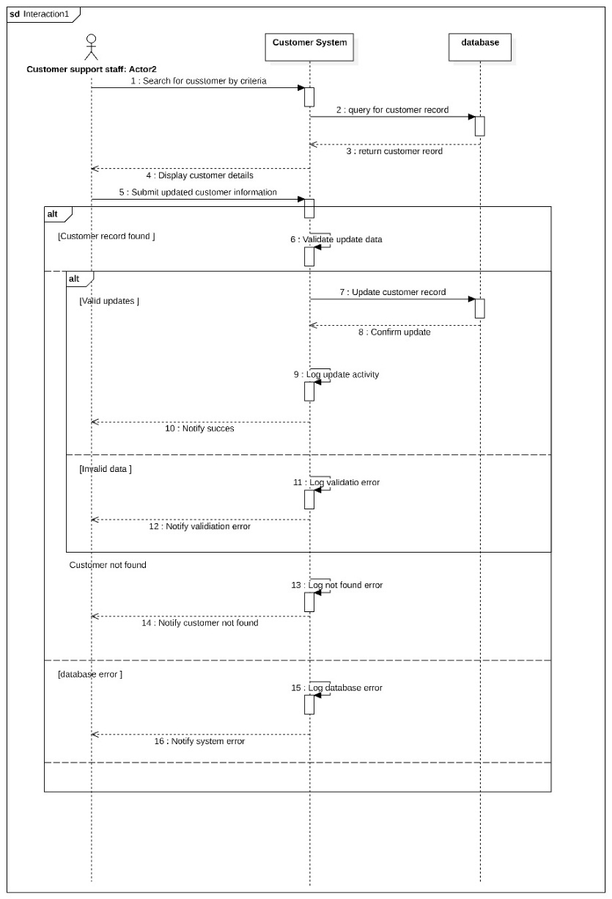

Assign Order to Rider :
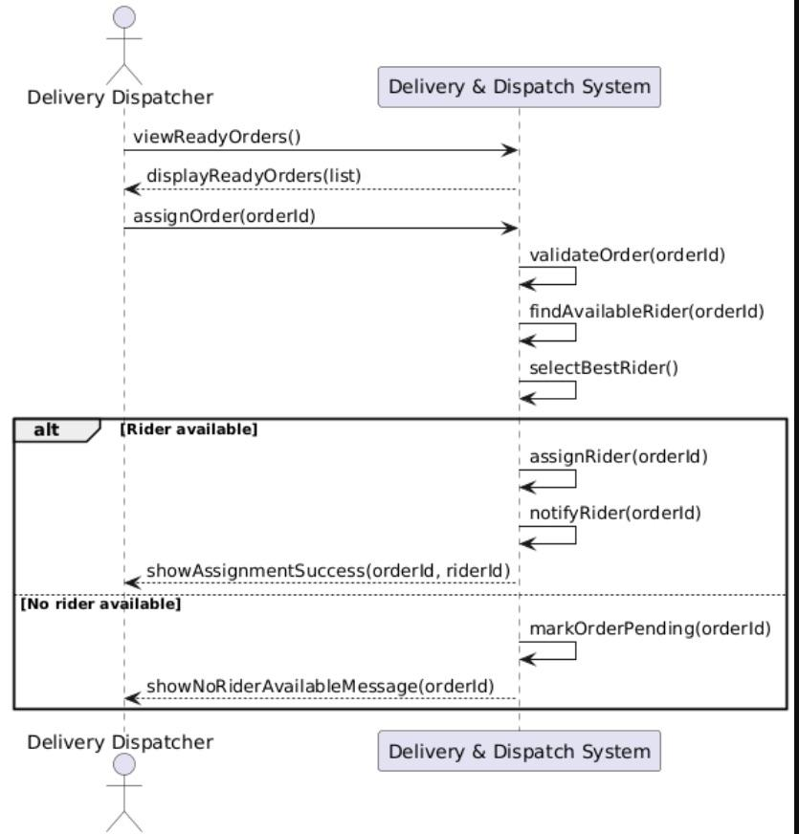
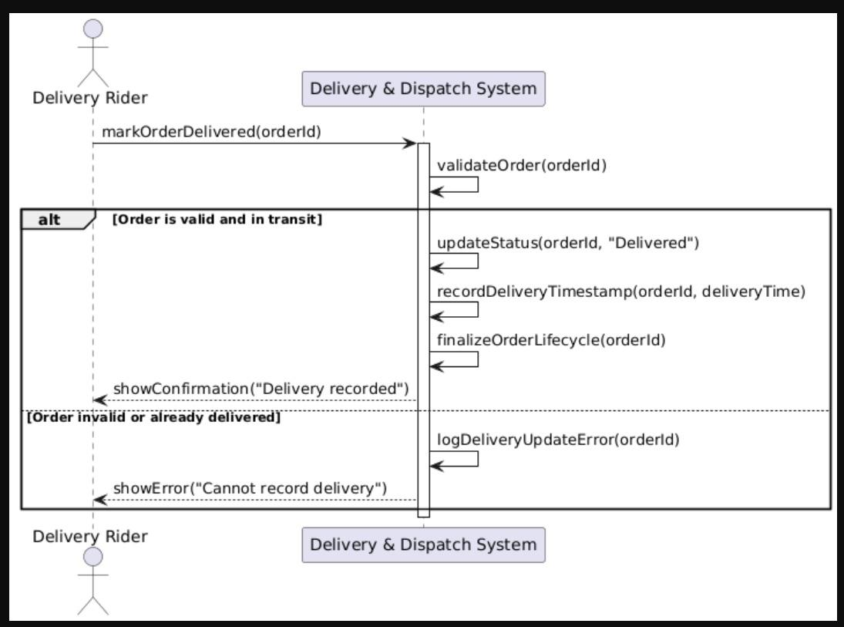
Record Order Delivery
Retrieve Order Status: Cancel order:

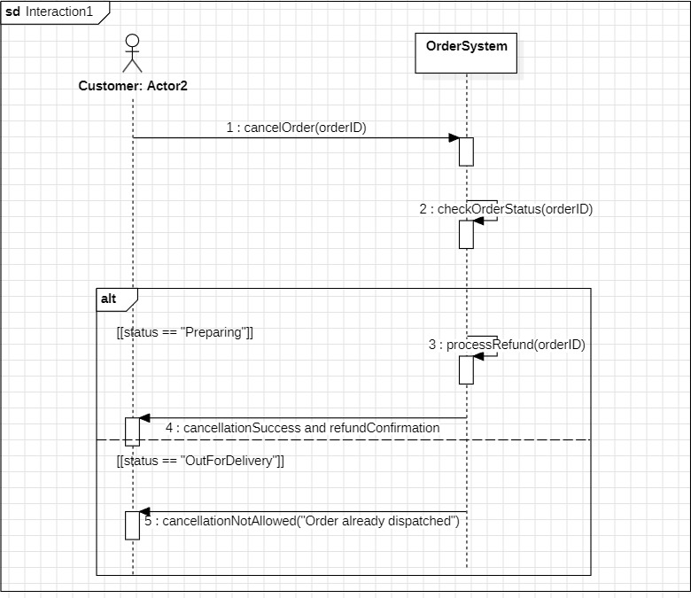
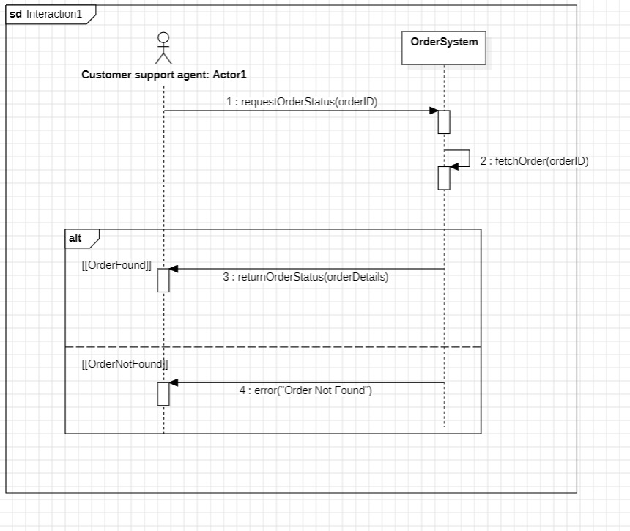

State Machine
Delivery :
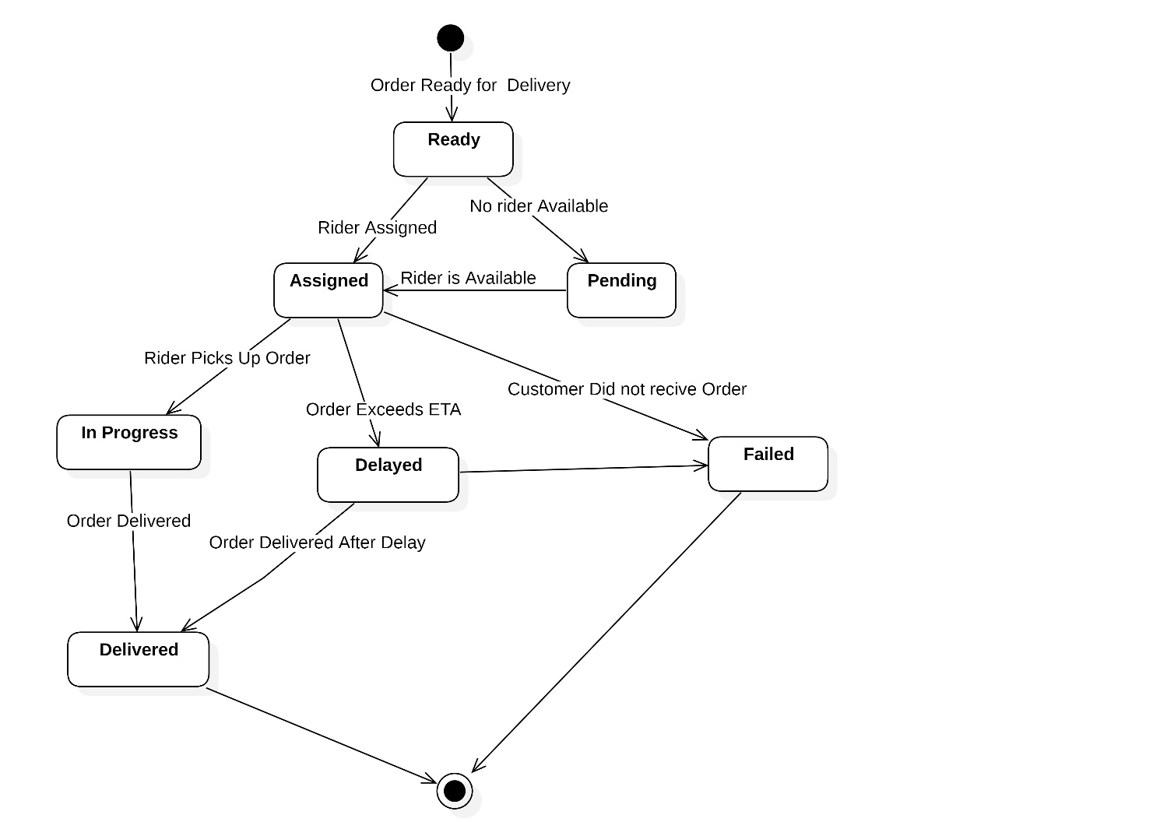

Complaint state machine:
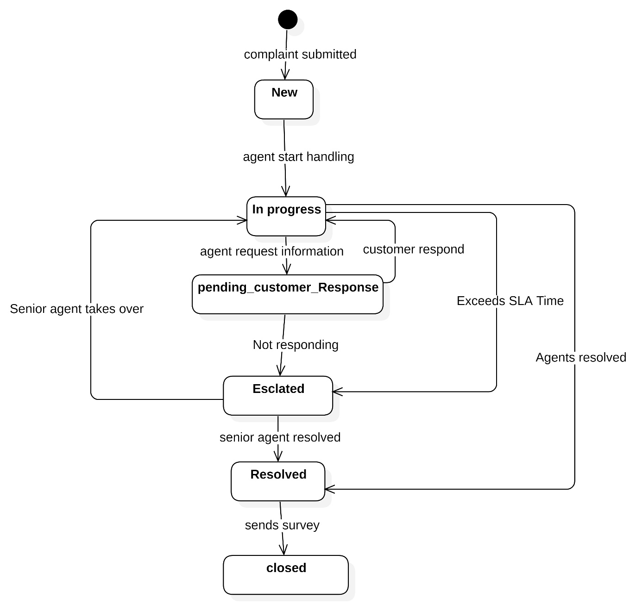

Jira screenshots:
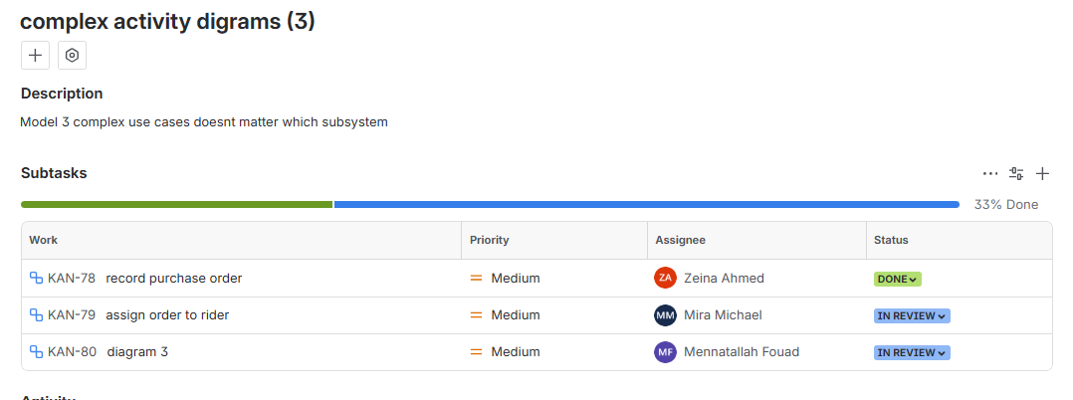
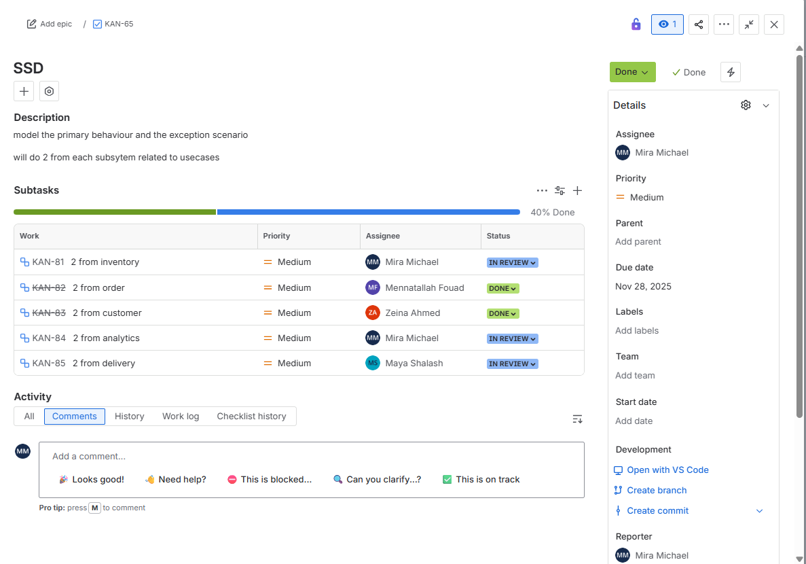
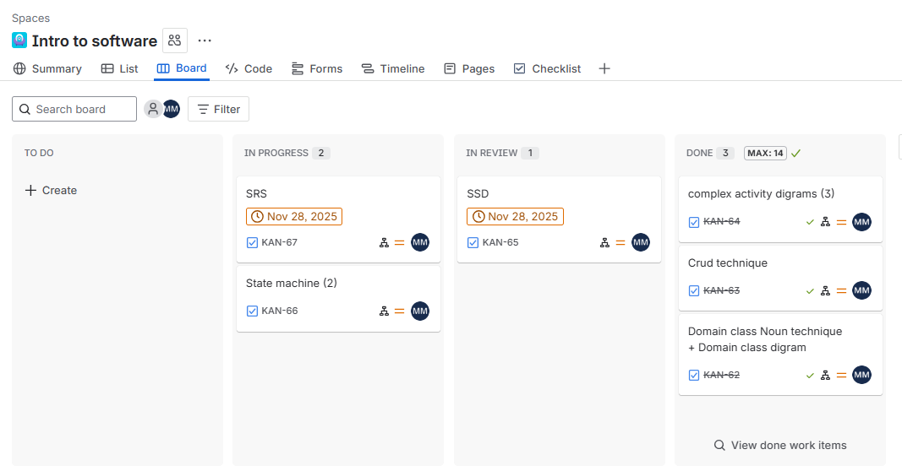

Github:
